**User Documentation**

**General description:** The application presents a cloud computing trivia game, its main goal is to teach the user cloud computing from the basic level to an advanced level.

The user can log in or sign up to enter the application. The app includes these screens: Login page, Sign Up page, Landing page, Tutorial page, Add question page, Edit Question page, Leaderboard Page, Admin page, Game page, Results game via graph page, Rank Shop page

**The target audience:** People who are interested in learning cloud computing or expanding and deepening their knowledge.

**Login page :**



Page description:

* Login page allows existing users to enter their user details such as username and password, validates details entered by the user against the stored data to confirm the users access rights.

This page has two buttons:

* "Login" button: By clicking this button if the user exists then it will connect him to the game and move him to the landing page.
* "Sign Up" button : Clicking on this button will redirect to the Sign Up page to let new users create a new account if they don't have one.

Common mistakes in the page:

* If the user has entered incorrect data such as a wrong password or incorrect username and tries to connect, the page displays a message prompting the user that their input is incorrect. The message will be User not found!
* The user has not entered anything.

**Sign Up page:**

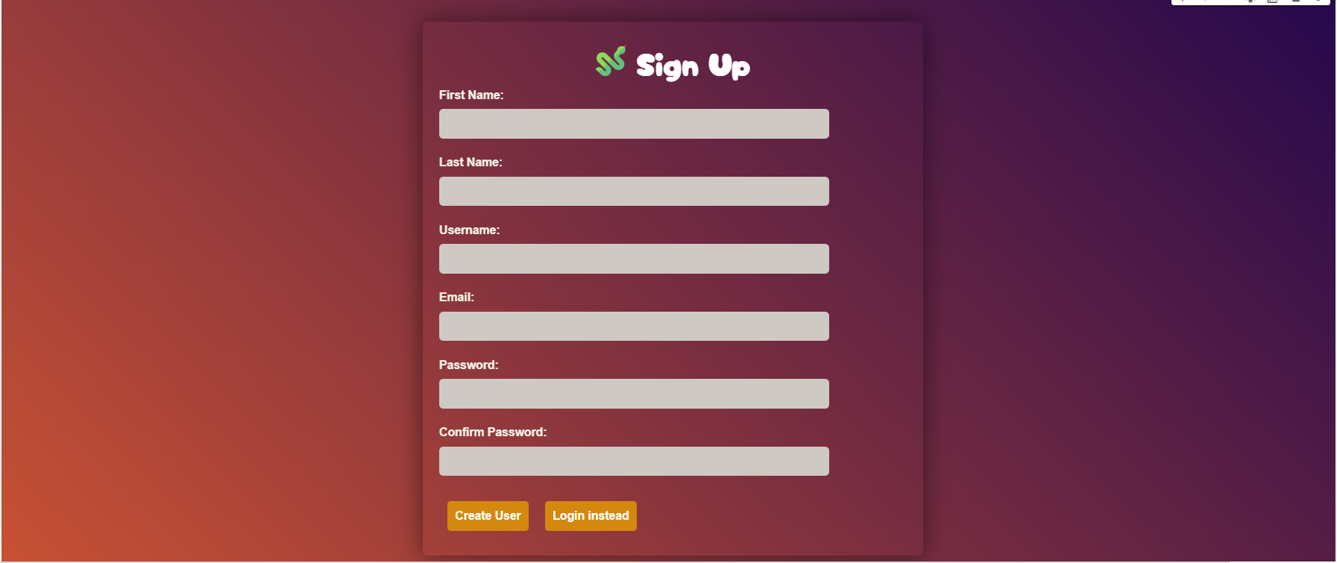

Page description:

* The Sign Up page will allow new users who do not have an account to create a new account by entering these details: first name, last name, username, email, password and password verification, then saves the data in the game database.

This page has two buttons:

* "Login instead" button: This button will return the user to the login page.
* "Create User" button: After entering the details and pressing this button, it will move the user back to the login page after he has already entered the details and created a new account, after this step the new user will have an account and can then make a login like users who already have an existing account.

**Landing page:**

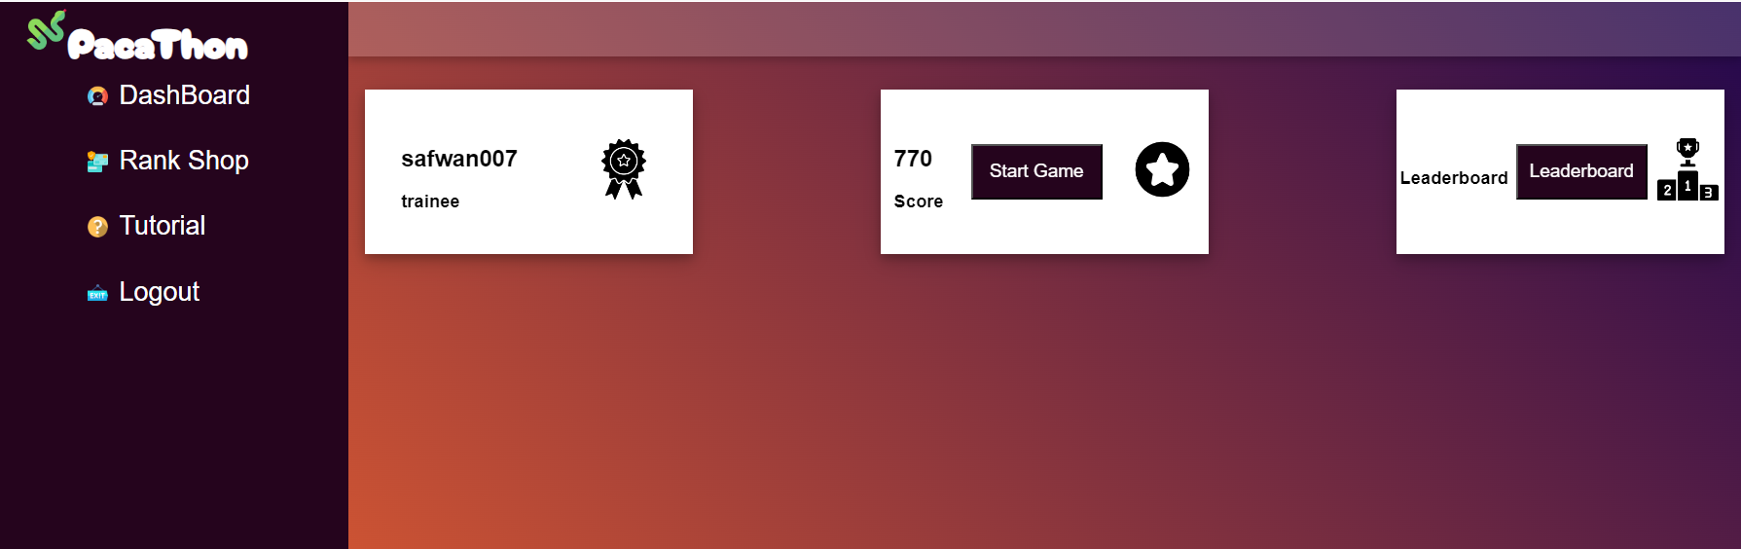

Page description:

* This is the main page in the game, we moved to it after a successful login attempt. The user will be able to see his level along with his username in the game, example for the level is: trainee, he will also be able to see his score, and how many points he had gained in the game, they will also be able to see the leaderboard of the five leading players in the game.

This page has several buttons:

* "Start Game" button: Clicking this button will move the user to start the game (to the questions).
* "Leaderbord" button: Clicking on it will move the player to the page of the top five Leaders in the game.
* "Tutorial" button: Clicking this button will move the player to a tutorial page.
* "Logout" button: Clicking on it will log the user out and takes the user back to the login page.
* "Rank Shop" button: Clicking on it will redirect to the rank purchase page. Purchase rank page is useful for purchasing different ranks, the user can only buy ranks that match the score he has.

**Tutorial page:**



Page description:

* This page shows a tutorial, a short explanation of the game, comments about important things in the game that will help the user understand more things and make better progress in the game.

This page has one button:

* "Back" button: if the users click on this button it will move them back to the main page.

**Add Question page:**

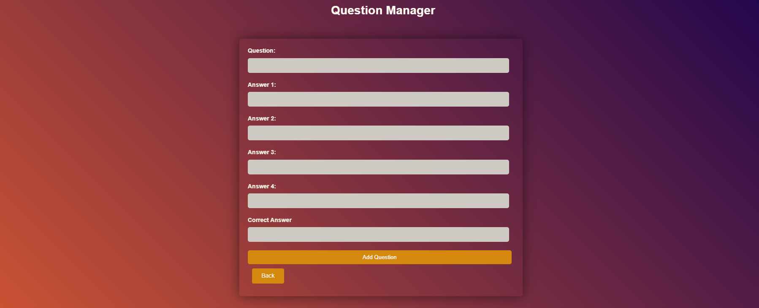

Page description:

* This page is only accessible to the manager. It allows the manager to add a question with 4 possible of answers, the manager will be asked to enter the question, first answer, second answer, third answer, fourth answer, and finally the correct answer among the 4 answers and then click on the Add Question button.

This screen has two buttons:

* "Back" button: returns the manager to the previous page of manager Tools (the main page of the manager).
* "Add Question" button: This button will add and store the question and answers entered by the manager then it leaves the manager on the same page.

**Common mistakes in the page:**

* If the manager did not enter certain information to the form (left a certain field blank, for example the third answer) the page will provide an appropriate message close to the empty field to show and help the manager understand what is not good and why.

**Edit Question page:**

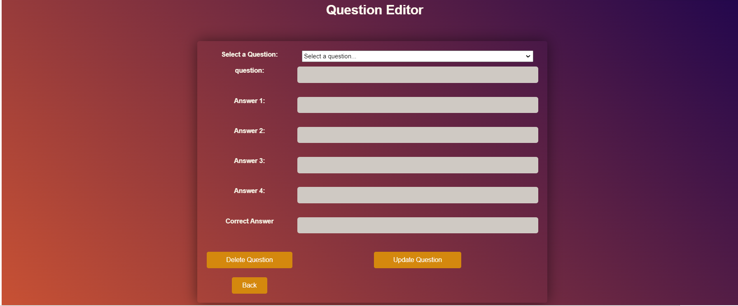

Page description:

* This page is only accessible to the manager. This page allows the manager to update an existing question with 4 answer options, the manager will be asked to select an existing question and then all the old answers will be updated automatically. The manager can delete or change the necessary fields then clicks on Update question button.

This page has three buttons:

* "Back" button: Returns the manager to the previous page of manager Tools (the main page of the manager).
* "Update question" button: The question will be updated in the database and will leave the manager in the same page.
* "Delete question" button: The question will be deleted from the database and will leave the manager in the same page.

Handling invalid operations/inputs by the user:

* If the manager tries to update a question before he has even entered anything, and before choosing which question he would like to update, then he will see a message that says “you need to select an item from the list”.
* If the manager tries to delete a question before he has even entered anything, and before choosing which question he would like to update, then he will see a message that says “you need to select an item from the list”.

**Leaderboard Page:**

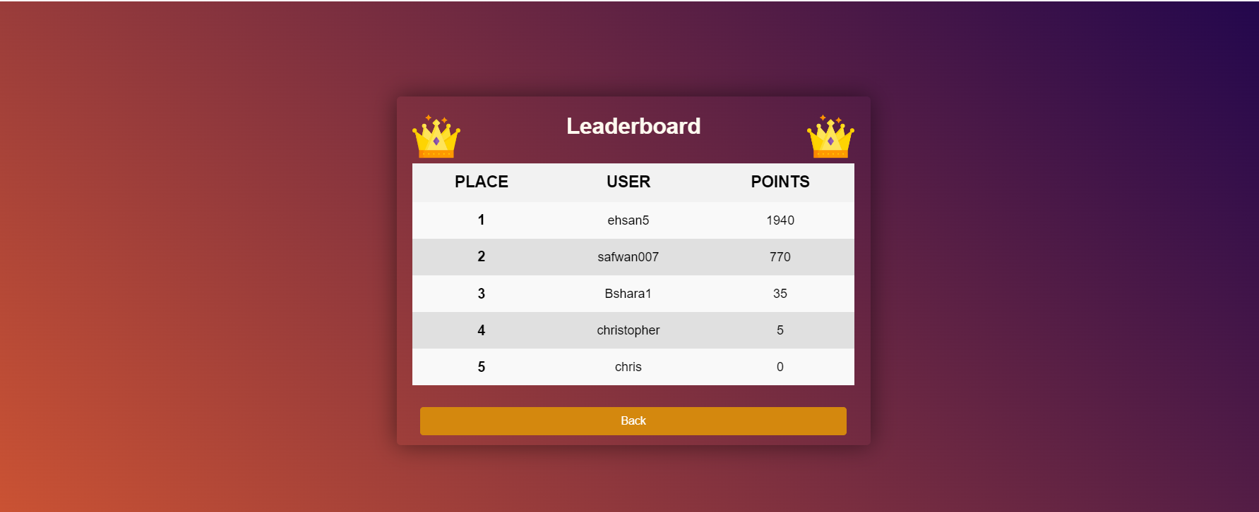

Page description :

* The player can see the top five players with the highest score and each player’s points.

This page has one button:

* "Back" button: Clicking on this button will return the user to the landing page.

**Admin page:**



Page description:

* This page is only for admin.

The page shows the actions that the admin can perform in the system.

This page has three buttons:

* "Add Question" button: Clicking on this button opens a new page for adding new questions.
* "Edit Questions" button: Clicking on this button opens a page that allows the admin to edit the saved questions in the database.
* "Logout" button: Clicking on this button returns the admin to the login page.

Note: the admin cannot log in as a player; if he wants to play, he should create a new user account and log in as a player.

**Game page :**

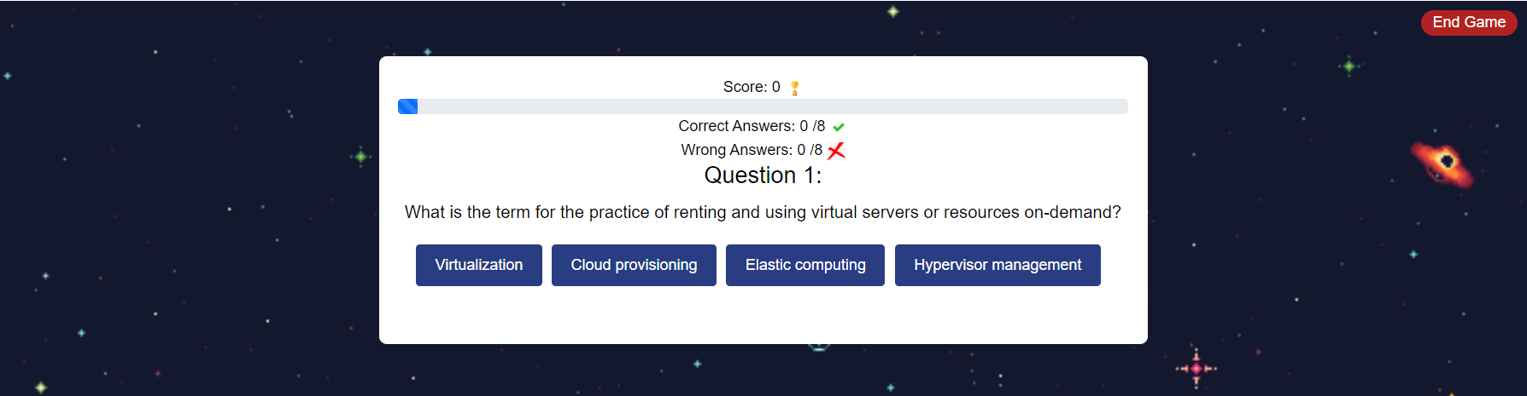

Page description :

* The game includes 8 questions about cloud computing; for each question, there are four options, one of them is the correct answer.
* Answering questions is done by choosing one answer from the options.
* The correct answer increases the total score by 10 points.  
  An incorrect answer decreases the total score by 5 points.

This page has three buttons:

* answers' buttons : Clicking on one of the answers' buttons will show the user if he answered correctly and display the correct answer.
* “Next” button : The “Next” button is not available until the player answers the first question, clicking on this button will show the next question.
* "End Game" button: The player can end the game whenever he wants by clicking on the "End Game" button. While ending the game, the score for the current game will be saved, Clicking on "End Game" displays the game results via graphs.

**Notes:**

* During the game, the player can see the number of questions he answered correctly and the number of questions he answered incorrectly.
* The user can also see his score, The score is updated as the user answers a question.
* The progress bar shows the player how far along he is in the game.
* The progress bar's value increases whenever the user presses "Next".

Common mistakes in the page:

* the player can click on "End Game" button by mistake even though he didn't want to end the game and then he can't go back to continue the game.

**player answers correctly:**

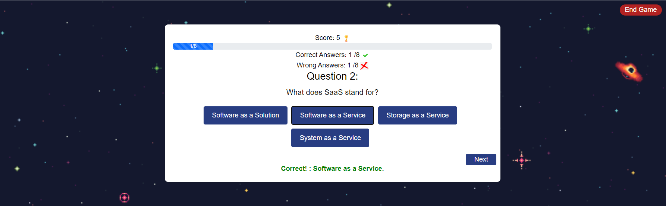

* Below the question the player can see his answer (correct answer)

This page has one button:

* "Next" button : Clicking on this button displays the next question.

**Note:** The player can skip the current question by clicking on "Next" without choosing one of the options, but he can't go back to the skipped question.

Common mistakes in the page:

* If the player did not properly read the game instructions, he may accidentally press this button and skip a question even though he meant to answer it.

**player answers incorrectly:**

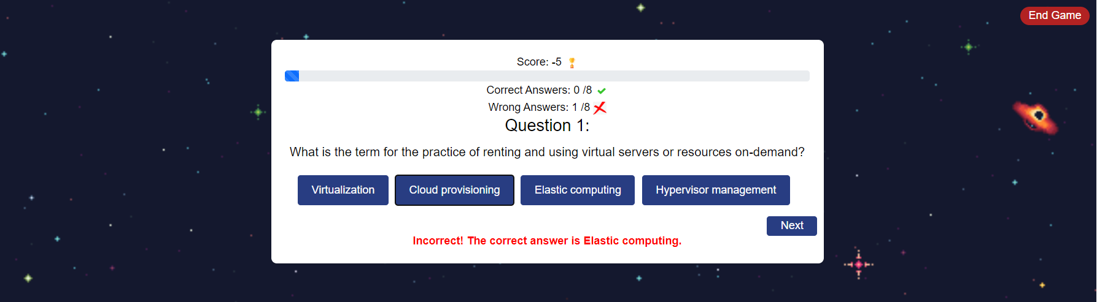

* Below the question the player can see his answer (incorrect answer)

This page has one button:

* "Next" button : Clicking on this button displays the next question.

Common mistakes in the page:

* If the player did not properly read the game instructions, he may accidentally press this button and skip a question even though he meant to answer it.

**Results page :**



Page description:

* This page will be displayed when the player has seen all the questions.

This page has one button:

* "End Game" button: Clicking on this button displays the game results via graphs.

**Results game via graph page:**

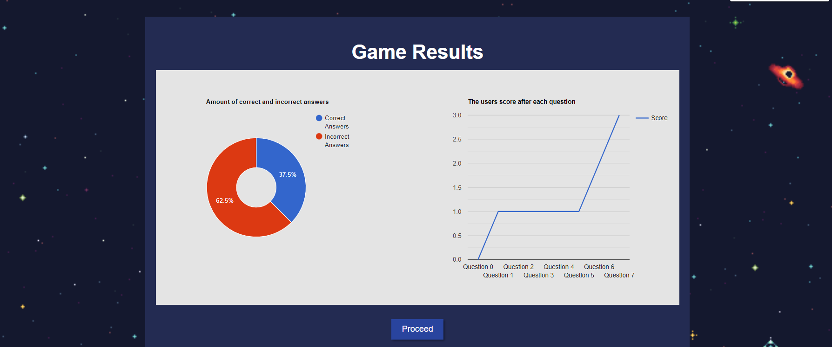

Page description :

* This page includes 2 graphs which display the results of the game the user had played, the graph on the left shows the user the percentage of correct and incorrect answers he had, the right graph shows the player his score after answering each question.

This page has one button:

* "Proceed" button : The player can close this page and return to the dashboard by clicking on "Proceed".

**Rank Shop page:**

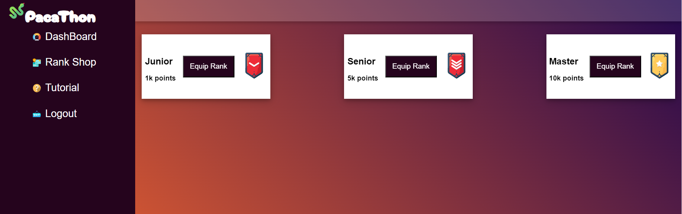

**Page description:**

* This page shows the ranks the player can purchase after he earns enough points.

The user can buy a rank according to his score:

* + 1K points for "Junior" rank.
  + 5K points for "Senior" rank.
  + 10K points for "Master" rank.

This page has three button:

* "Equip Rank" buttons : Clicking on one of the "Equip Rank" buttons opens the dashboard, and the user can see the updated rank in the dashboard.